MGNREGA PERFORMANCE ANALYSIS
An Interactive Power BI Dashboard for District-wise Employment, Expenditure and Works Monitoring

Mini Project Documentation

MGNREGA TAMIL NADU PERFORMANCE DASHBOARD
Mini Project Report — Excel & Power BI

1. Project Overview and Objective
This project involves cleaning, transforming, and analysing MGNREGA (Mahatma Gandhi National Rural Employment Guarantee Act) scheme data for Tamil Nadu using Excel, and creating an interactive Power BI dashboard to derive meaningful insights into rural employment generation, wage disbursement, and work completion across districts.
The main objective is to demonstrate data pre-processing techniques using Excel and build an interactive Power BI dashboard that tracks scheme performance — expenditure utilization, employment days, wage payments, and gender participation — across districts of Tamil Nadu, supporting informed decision-making for rural development planning.

2. Data Sources
- Source Description and Timeline: Government open data / MGNREGA MIS reports (data.gov.in), district-wise and month-wise records for Tamil Nadu.
- Domain: Government / Rural Development & Employment Analytics.

3. Objectives
- To analyse district-wise total expenditure and employment generation under MGNREGA in Tamil Nadu.
- To evaluate average wage payment and average employment days provided per household across districts.
- To track work completion status (completed vs. ongoing works) and monitor active job cards and active workers for scheme oversight.

4. Attribute (Column / Features) Details
Attribute Name | Data Type | Description
district_name | Text (Categorical) | Name of the district in Tamil Nadu
Month | Date / Categorical | Month of the record, from the Month dimension table
Total_Households_Worked | Numeric (Integer) | Number of households that received work under the scheme
Total_No_of_Active_Job_Cards | Numeric (Integer) | Count of active job cards issued in the district
Total_No_of_Works_Takenup | Numeric (Integer) | Number of works taken up in the district
Women_Persondays | Numeric (Integer) | Persondays of employment generated for women workers
No_of_Workers | Numeric (Integer) | Number of active workers recorded
Completed_Works | Numeric (Integer) | Number of works completed
Ongoing_Works | Numeric (Integer) | Number of works currently in progress

5. Tools & Technologies
- Excel: Data cleaning, transformation, and Pivot Tables.
- Power BI: Data modelling, DAX calculations, visualization, and interactive dashboard creation.

6. Data Pre-Processing (Excel / Power Query)

Tasks Performed:
- Data Cleaning & Transformation: Removed duplicates and missing values, standardized district name formats, and created calculated fields for downstream measures.
- Filtering & Sorting: Organized records by district and month to keep only relevant, scheme-related data.
- Pivot Tables: Generated Pivot Tables in Excel for initial summarization of expenditure, employment days, and work status before building the Power BI model.
- Fact / Dimension Split: Converted the raw dataset into a Fact table (MGNREGA — district & month-level records) with supporting Dimension tables (MonthTable for the time dimension, and a dedicated Measure table for DAX measures).

7. Data Modelling and DAX (Power BI)

Data Model:
The model uses three tables: MGNREGA (fact table holding district-wise and month-wise scheme records), MonthTable (a date/month dimension related to MGNREGA on Month), and Measure table (a disconnected table used to organize all DAX measures separately from the data tables for cleaner maintenance).
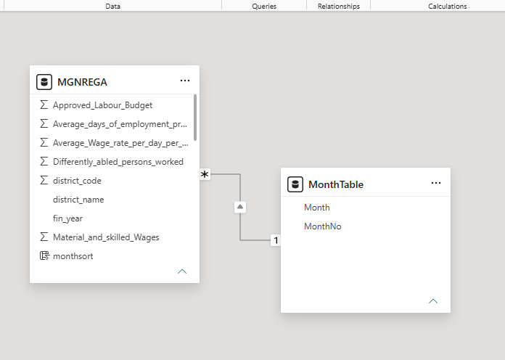

Calculated Columns & DAX Measures:
Measure | Purpose
Total Expenditure | Sums total scheme expenditure, used in KPI cards, bar and line charts
Average Wage | Average wage paid per workday across the selected districts/period
Average Employment Days | Average number of employment days provided per household
Active Workers | Count of currently active workers, used in the job-card/worker comparison chart
Approved Labor Budget | Approved labor budget allocated for the scheme, shown as a KPI card on Page 2

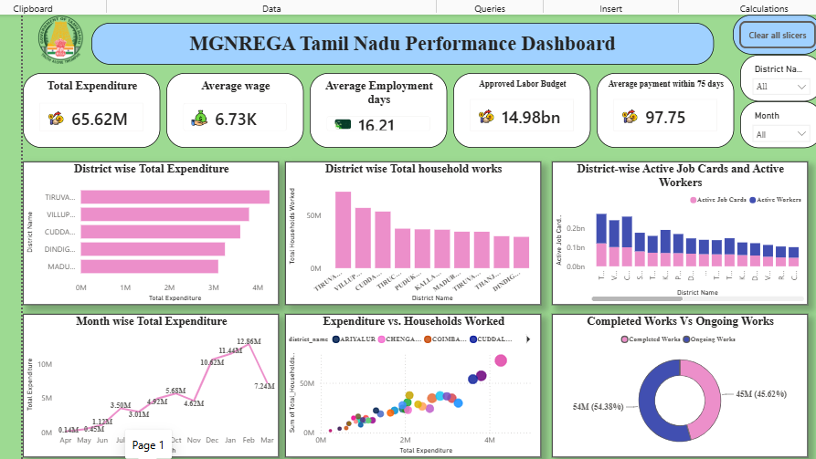

8. Analysis and Visualizations (Power BI)

Page 1 — Overview:
- KPI Cards: Total Expenditure, Average Wage, Average Employment Days, Women Participation %
- Line Chart: Month-wise Total Expenditure (trend)
- Clustered Bar Chart: District-wise Total Expenditure
- Column Chart: District-wise Total Household Works
- Column Chart: District-wise Active Job Cards and Active Workers
- Scatter Chart: Expenditure vs. Households Worked
- Donut Chart: Completed Works vs. Ongoing Works
- Slicers: District and Month; an action button for page navigation

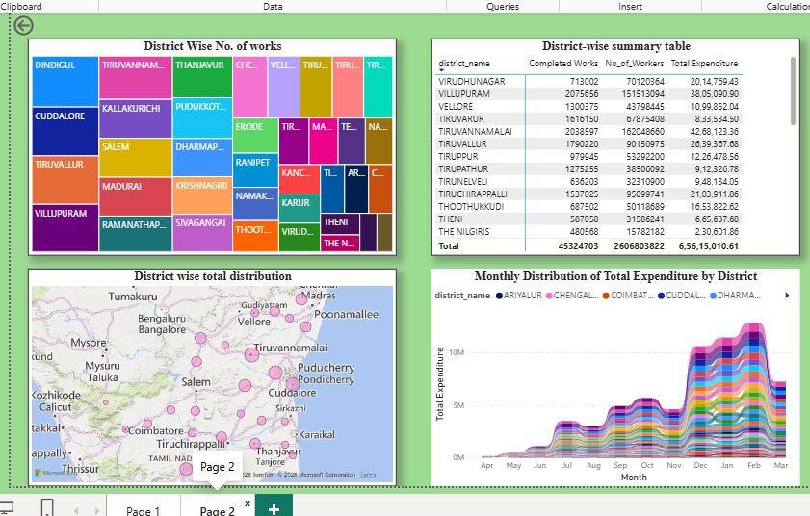Page 2 — District Detail:
- Map: District-wise Total Distribution
- Treemap: District-wise Number of Works
- Ribbon Chart: Monthly Distribution of Total Expenditure by District
- Pivot Table: District-wise Summary
Report interactivity: cross-filtering between visuals via the District and Month slicers, drill-down enabled on district/month hierarchies, and an action button linking Page 1 to the Page 2 detail view.

9. Insights & Conclusions (SMART)
Fill in the bracketed values below with the actual figures read off your dashboard for each visual:

Visual 1: KPI Cards

KPIs

Total Expenditure = ₹65.62 Million

Approved Labour Budget = ₹16 Billion

Average Wage = ₹6.73K

Average Employment Days = 16.21 Days

Average payment percentage = 97.75%

SMART Analysis for Overall KPI Cards

Descriptive Analysis:

The dashboard indicates an overall Total Expenditure of ₹65.62 Million against an Approved Labour Budget of ₹16 Billion. Workers received an Average Wage of ₹6.73K, with an Average Employment of 16.21 days per household, while 97.75% of wage payments were successfully completed within the prescribed timeline.

Diagnostic Analysis:

The high payment efficiency (97.75%) demonstrates an effective wage disbursement system. However, the average employment of 16.21 days is considerably below the MGNREGA guarantee of 100 days, suggesting that employment opportunities remain underutilized despite the availability of a substantial labour budget.

Predictive Analysis:

If current implementation and fund utilization continue, expenditure is expected to increase steadily as more employment opportunities are generated. Maintaining the current payment efficiency will likely enhance worker participation and improve programme performance in the coming months.

Prescriptive Analysis:

To maximize the effectiveness of the scheme, administrators should increase the number of labour-intensive works to improve employment days, optimize utilization of the ₹16 Billion labour budget, sustain the 97.75% timely payment rate, and continuously monitor district-wise expenditure to ensure balanced fund allocation and improved rural employment outcomes.

________________________________________

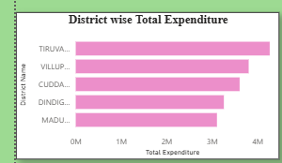

Visual 2: District-wise Total Expenditure (Clustered Column Chart)

Descriptive

Tiruvannamalai recorded the highest expenditure (₹4.27 million), while Villupuram and Cuddalore followed with ₹3.81 million and ₹3.61 million, respectively.

Diagnostic

Districts with higher expenditure are likely implementing a greater number of MGNREGA works and employing more workers.

Predictive

These districts are expected to continue leading if current project implementation and fund allocation remain consistent.

Prescriptive

Adopt the implementation practices of top-performing districts in districts with lower expenditure.

________________________________________

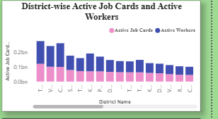

Visual 3: Active Job Cards vs Active Workers (Clustered Bar Chart)

Descriptive

The number of active workers is consistently high across districts and corresponds closely with the number of active job cards.

Diagnostic

This indicates good workforce registration and participation under the MGNREGA scheme.

Predictive

Districts with more active job cards are expected to generate higher employment opportunities in future months.

Prescriptive

Increase awareness campaigns to register eligible households and activate inactive job cards.

________________________________________

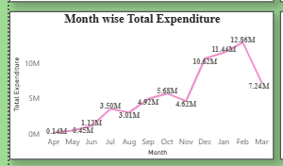

Visual 4: Monthly Expenditure Trend (Line Chart)

Descriptive

Monthly expenditure fluctuates throughout the financial year, with higher spending observed during peak implementation months.

Diagnostic

The variation in expenditure reflects differences in work execution, labour demand, and fund utilization across months.

Predictive

If the current trend continues, expenditure is likely to remain higher during months with increased project activity.

Prescriptive

Plan work schedules evenly throughout the year to ensure balanced expenditure and efficient resource utilization.

________________________________________

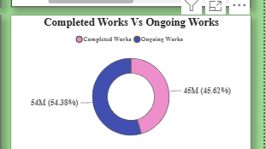

Visual 5: Completed vs Ongoing Works (Donut Chart)

Descriptive

The Donut Chart compares the proportion of completed and ongoing MGNREGA works across Tamil Nadu. A total of 54.04 million works are currently ongoing, while 45.32 million works have been completed.

Diagnostic

A larger share of ongoing works indicates that many projects are still under execution and have not yet reached completion.

Predictive

Most ongoing works are expected to transition into completed works in the upcoming months.

Prescriptive

Strengthen project monitoring and timely execution to increase the work completion rate.

________________________________________

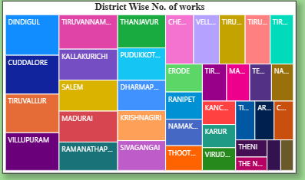

Visual 6: District-wise Works (Treemap)

Descriptive

The Treemap visualizes the distribution of Total Expenditure across Tamil Nadu districts. Tiruvannamalai recorded the highest expenditure at ₹4.27 million, followed by Villupuram (₹3.81 million), Cuddalore (₹3.61 million), Dindigul (₹3.26 million), and Madurai (₹3.11 million).

Diagnostic

Larger blocks represent districts implementing more projects, indicating stronger programme activity.

Predictive

These districts are likely to continue contributing significantly to employment generation.

Prescriptive

Provide additional technical and financial support to districts with fewer works.

________________________________________

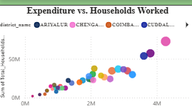

Visual 7: Employment Generation vs Expenditure (Scatter Chart)

Descriptive

The Scatter Chart illustrates the relationship between employment generation and total expenditure across Tamil Nadu districts. Tiruvannamalai recorded the highest expenditure of ₹4.27 million and is positioned among the districts with the highest employment generation. The overall expenditure across all districts is ₹65.62 million.

Diagnostic

The chart indicates a positive relationship between expenditure and employment generation. Districts with higher expenditure generally generated more employment opportunities, suggesting that increased investment supports greater rural employment under MGNREGA.

Predictive

If expenditure continues to increase in high-performing districts, employment generation is expected to rise further. Districts currently showing lower expenditure and employment can improve their performance through better implementation and increased fund utilization.

Prescriptive

Prioritize funding and monitoring in districts with strong employment outcomes while providing additional support to lower-performing districts. Adopting the implementation practices of districts such as Tiruvannamalai can help improve employment generation across Tamil Nadu.________________________________________

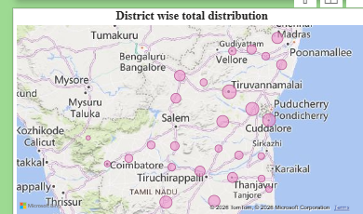

Visual 8: District-wise Expenditure (Filled Map)

The Filled Map displays the geographical distribution of ₹65.62 million in MGNREGA expenditure across Tamil Nadu. Tiruvannamalai recorded the highest expenditure at ₹4.27 million, followed by Villupuram (₹3.81 million), Cuddalore (₹3.61 million), Dindigul (₹3.26 million), and Madurai (₹3.11 million).

Diagnostic

The darker-shaded districts on the map indicate higher expenditure, reflecting stronger implementation of MGNREGA activities and greater fund utilization. Tiruvannamalai emerged as the leading district, while districts with lighter shading recorded comparatively lower expenditure.

Predictive:If the current implementation trend continues, Tiruvannamalai, Villupuram, and Cuddalore are expected to remain the highest-performing districts. Lower-expenditure districts are likely to improve with increased project execution and better fund utilization.

Prescriptive

Strengthen planning, monitoring, and fund allocation in lower-performing districts. Replicating the implementation strategies of Tiruvannamalai and other top-performing districts can help achieve balanced expenditure and improve employment generation across Tamil Nadu.________________________________________

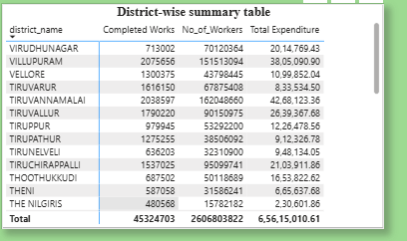

Visual 10: Matrix/Table

Descriptive

The Matrix provides district-wise values for expenditure, employment, workers, and works executed.

Diagnostic

It enables detailed comparison between districts and helps identify variations in scheme performance.

Predictive

Districts consistently showing higher values are expected to remain top performers.

Prescriptive

Use district-level comparisons to allocate resources efficiently and improve performance in weaker districts.

________________________________________

Overall Dashboard Insight

Descriptive Analysis

The MGNREGA dashboard provides a comprehensive overview of the scheme's financial and employment performance. During the selected period, the scheme recorded a Total Expenditure of ₹65.62 Million against an Approved Labour Budget of ₹16 Billion. Workers received an Average Wage of ₹6.73K, while households obtained an Average Employment of 16.21 days. Additionally, 97.75% of wage payments were successfully processed within the prescribed timeline, demonstrating strong payment efficiency.

Diagnostic Analysis

The dashboard indicates efficient financial management and timely wage disbursement, as reflected by the 97.75% payment rate. However, the average employment of 16.21 days is substantially below the MGNREGA entitlement of up to 100 days per household, suggesting that employment opportunities and labour budget utilization can be further improved. The gap between the ₹16 Billion approved labour budget and the ₹65.62 Million expenditure also indicates that a significant portion of the available funds remains unutilized.

Predictive Analysis

If current implementation trends continue, overall expenditure is expected to increase as more projects are sanctioned and executed. The consistently high payment efficiency is likely to encourage greater worker participation, while improved utilization of the approved labour budget could increase employment days and strengthen rural livelihoods in future reporting periods.

Prescriptive Analysis

To enhance the effectiveness of the MGNREGA programme, administrators should focus on increasing labour-intensive works to improve the average employment days, accelerate utilization of the ₹16 Billion labour budget, maintain the 97.75% timely payment performance, and regularly monitor district-wise expenditure and employment indicators. Prioritizing low-performing districts and reallocating underutilized resources can help maximize employment generation, improve budget utilization, and achieve the scheme's rural development objectives.

10. Conclusions
The integration of Excel and Power BI proved effective for end-to-end analysis of MGNREGA scheme performance in Tamil Nadu — from raw district-wise records to an interactive, drillable dashboard that highlights expenditure trends, employment generation, wage efficiency, and work completion status to support rural development decision-making.

